

|  |  |
| --- | --- |
| **Name** | **Shaham Hijab** |
| **Class** | **BS-AI** |
| **Reg. No** | **22-NTU-CS-1373** |
| **Lab** | **IOT** |
| **Submission To** | **Sir Nasir** |

1. **Upload the same code to a physical ESP32 S3**:
   * Run the code.
   * Take a snapshot of Thonny.
   * Record a short video of your physical device (change the pin from 33 to 48 for the physical device).

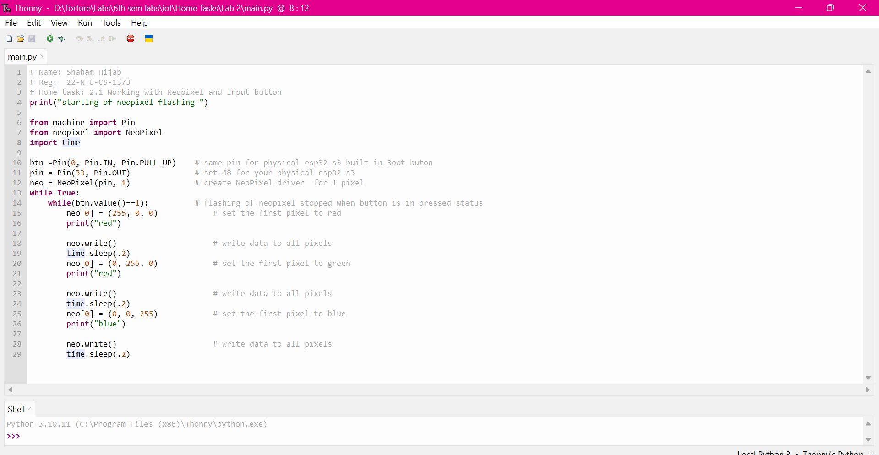

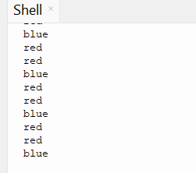

https://wokwi.com/projects/423335352988679169

1. **Investigate the Neopixel color behavior**:
   * Why does the Neopixel always turn blue when the button is pressed?
   * How can it be made to stop on different colors in real-time (e.g., sometimes red, sometimes green, sometimes blue)?

The LED always turns blue because, in the code, the button value is initially set to 1, causing the loop to run. When the button is pressed, the value changes to 0, which stops the loop. Since blue is the last color displayed in the loop, the LED consistently stops at blue.

To make the LED stop at different colors, we can use a list of colors and a variable (such as color_index) to keep track of the current color being displayed. By updating color_index before exiting the loop when the button is pressed, the LED will remain on the color it was showing at that moment. This approach prevents the LED from always stopping at blue, allowing it to stay on different colors instead.

1. **Modify the code for button presses**:
   * Change the color after every 5 button presses.
   * Examine the result: Does the color change exactly after 5 presses, or is there abnormal behavior?
   * If there is abnormal behavior, what could be the reason?

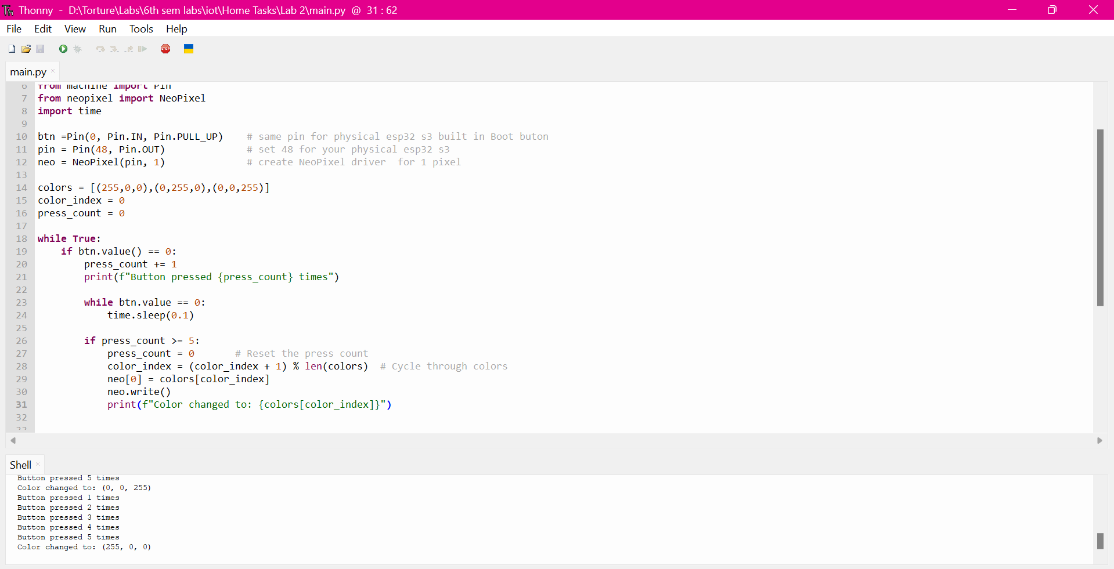

**Abnormal Behavior:**

* Color Changes Inconsistently: The LED might change color before or after exactly 5 presses.
* Multiple Counts for One Press: The button press might be counted multiple times, causing the color to change unexpectedly.
* No Color Change: In some cases, the color might not change at all, even after 5 presses.

https://wokwi.com/projects/423335410791447553